An assistant for the Virtual Music Centre
Casper Joost Eyckelhof

Abstract
For the UWISH project [1] an assistant has been built that helps people find their way in a virtual world. The virtual world in this case is the Virtual Music Centre [2] (VMC): a detailed VRML model of the Music Centre of Enschede, The Netherlands.
This paper describes the architecture of the assistant.

The Virtual Music Centre
The VMC has been built by the parlevink group of the department of computer science of the University of Twente [3]. Besides being a detailed model of the real music centre, it also contains a receptionist named Karin. Karin is an interface to a dialogue system (called SCHISMA) that makes it possible to query the database with performances using natural language and make reservations. Demonstrations of both the VMC and SCHISMA are available on the web [2].

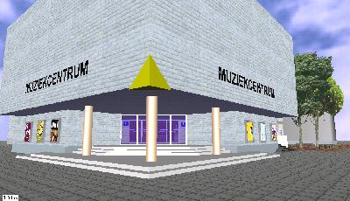 | 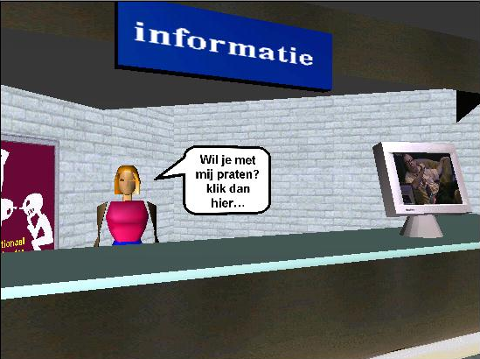

Basic ideas
The assistant is designed to help people based on their profile. A profile can contain all kind of properties about the user. In the current version a profile consists of a name, a profession, preferred means of transportation and several interest fields all of which the user can enter on first use and change at any time.

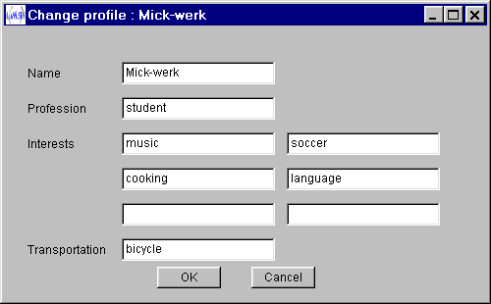

The help is offered in a different window, which is the only visible part of the assistant from the user.

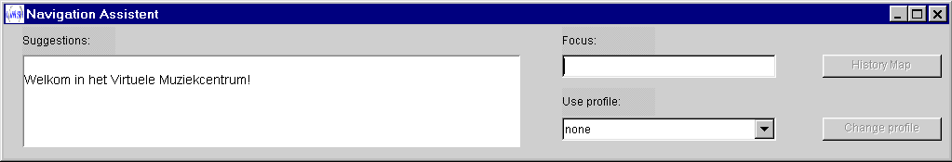

The navigation assistant can give advice through the suggestions field. This field holds HTML content: besides plain text it can contain hyperlinks and internal VRML links. Clicking hyperlinks opens a new browser window with the link, and clicking VRML links will transport the user to a different position within the virtual world.

Advice is given based on actions the user takes, the user profile and the history of the user. Actions can be several things, but the current version only uses (invisible) sensors that the user can trigger by walking through them. E.g. the profile contains an interest in catering and the user walks near a coffee bar in the VMC. At this point the assistant tells the user there is another bar upstairs, with an internal link to the other bar.
But the architecture allows for more action types: there is already a prototype that triggers on certain words that can occur in a dialog between the user and the receptionist of the VMC.

Architecture
The system is designed and built to be client-server. Every component has also been designed with an agent-based approach in mind. This basically means that all components can act on changes in the system.
On the client machine are running the VMC (in a browser using the cosmo plugin [4]), a java applet that monitors the virtual world, also inside the browser and finally the assistant which is a java application. The assistant includes a ‘communicator’ that is used for communication within the system.

On the server side there is a server (java application) that starts another communicator and the so-called SuperAgent. The SuperAgent is responsible for keeping the history, storing profiles and most important: generating advice. It does so by starting a few agents that all can respond on certain messages (usually actions by the user). The current agents have a (hard coded) rule base to give advice, but it’s very easy to add more sophisticated agents.

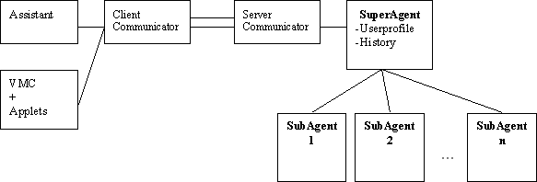

Communication
Communication between all parts of the system is done with communicators. Each component (applet, application) that wants to be able to send or receive has to register with a communicator. After registration it can send messages to every other component that has registered itself by using its name. The components don’t need to know whether their peer is on the same computer or somewhere on the other side of the world. There’s (at least) one communicator on every physical system and normal sockets are used for the communication between systems.
The messages themselves can contain all kind of information like profiles, actions and suggestions, but other types of messages can be added without interfering with the current implementation. The communication system is implemented in two java packages: one for communication and one for the messages.

PositionAgent
The only SubAgent that is fully functional at this point is the PositionAgent. It has a rule base that triggers on certain combinations of profile and position of the user.
if (evt.info.equalsIgnoreCase("koffiebalie") && parent.getUserProfile().interests.contains("catering")){
parent.handleResponse(new VMCResponseEvent("Ook de "+ link("koffieboven","koffiebalie boven") +
" is de gehele pauze geopend."));
}
In the sample code above, a message is sent to the assistant if the user triggers a sensor in the VMC near the coffee bar and the user has an interest in catering.
The way the rules are implemented in the current version is not very elegant, but it works. On the other hand, it is relatively easy to build better agents that can be plugged in to the system. The only thing they need to do is accept VMCMessages and respond using the handleResponse method of the SuperAgent.

Privacy considerations

If the system will ever be used in a production environment there are some things that have to be considered with respect to privacy of the user. At this point the profile is stored on the server side, which means that the provider of the service can harvest a lot of information about the users. There are several ways to address this problem, but that is beyond the scope of this article.

Future developments

The architecture itself doesn’t seem to need much more work: maybe some enhancements in the user interface and a better integration in to the web browser. It would be nice if the user didn’t have to start a separate application.
The important developments should be in the subagents. Those can be made much smarter. Everything is allowed as long as they support the two methods mentioned earlier: one to accept messages and one to send advice. It would be nice to use external rule bases to prevent having to recompile the server every time a rule is added, removed or changed. But subagents don’t have to be rule-based: some kind of reasoning system could be included in a subagent.
A prototype of a ‘DialogAgent’ has already been built. This agent responds to dialog events: when the user interacts with the receptionist of the VMC all text is monitored and sent to the server. At this point the DialogAgent uses a simple word spotting algorithm and a rule base like the PositionAgent. E.g. when the word ‘zaal’ (auditorium) is spotted, the agent will offer the user a direct link to the auditorium. But it is possible to build an agent that uses more sophisticated techniques to interpret the dialog and give advice based on it.

References
1. http://www.cwi.nl/projects/uwish/
2. http://parlevink.cs.utwente.nl/Projects/Muziekcentrum/index.html
3. http://parlevink.cs.utwente.nl/
4. http://www.cai.com/cosmo/

